Timber Cove
Recreation Association 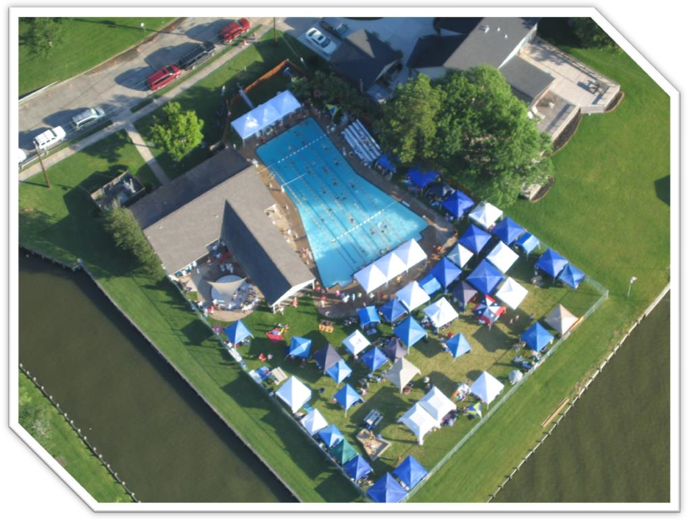 2024 Members Handbook

Visit our website
www.timbercovepool.com
Timber Cove
Recreation Association
2024 Board of Directors

President vacant

Vice President Gregg Stansfield | 281-380-9287 | g.stansfield@comcast.net
Secretary Sheryl Kuhfeldt | 281-326-1560 | slkuhfeldt@comcast.net
Treasurer Brad Jorgenson | 832-722-2991 | bpjorgenson@comcast.net
Memberships Buddy & Debbie Clark | 832-864-2128 | wclark16@gmail.com
Lifeguards Sarah McGregor | 832-452-6708 | sporkery@yahoo.com
Social Events Vacant

Private Parties Pat &Jane Brant | 832-715-0919 | brantjane@yahoo.com
Communications Debbie Clark  Swim Team/ Andrew True  TCRA Liaison | 832-864-2128  859-948-7740 | wclark16@gmail.com  TimberCoveDophins@yahoo.com

All TCRA Board members are volunteers. If you are interested in being a part of the TCRA Board, or would like to help with any project, contact any board member.

www.timbercovepool.com

The History of Our Pool Design

The Timber Cove Recreation Association (TCRA) pool was designed to commemorate NASA’s Mercury Program and opened on July 4, 1963. The shape of the pool is fashioned in precise dimensions after the Mercury capsule and honors four of the original Mercury Seven astronauts who lived in Timber Cove at that time, John Glenn, Scott Carpenter, Gus Grissom and Wally Schirra. The cost of the pool, without the clubhouse, was $17,316.00

The TCRA pool is a wonderful amenity in our neighborhood and has been a place for gatherings since it opened. It is a private organization operated and maintained almost exclusively by its member volunteers. Annual funding for the pool comes from membership dues and donations only. The pool receives no financial subsidies from any other Timber Cove organization and no general payments or fees from the neighborhood.

If you are interested in being a part of the TCRA Board or would like to help with any project, contact any board member.

We always welcome interested members to join in the operations of the pool.

2024 Membership Form and Fee Schedule
(Click above link to access form and fee schedule)

Please make check payable to: TCRA

Deliver payment to:
Buddy and Debbie Clark
122 Lazywood Lane
832-864-2128

Or

Brad and Kay Ann Jorgenson
103 Driftwood Dr.
832-722-2990

PLEASE NOTE: If you pay by May 5 your front door code will remain the same as the previous year. If you pay after May 5 your front door code will be deactivated and a new code will be sent to you after payment has been received.

Timber Cove
Recreation Association
2024 Pool Operation Hours
(When Lifeguards Are on Duty)

June 1 - until school starts in August
12:00 – 6:00 pm
(Unless notified via the Remind App)

PLEASE NOTE: After hour use of the pool facilities is restricted to members 21 years of age or older with code access only.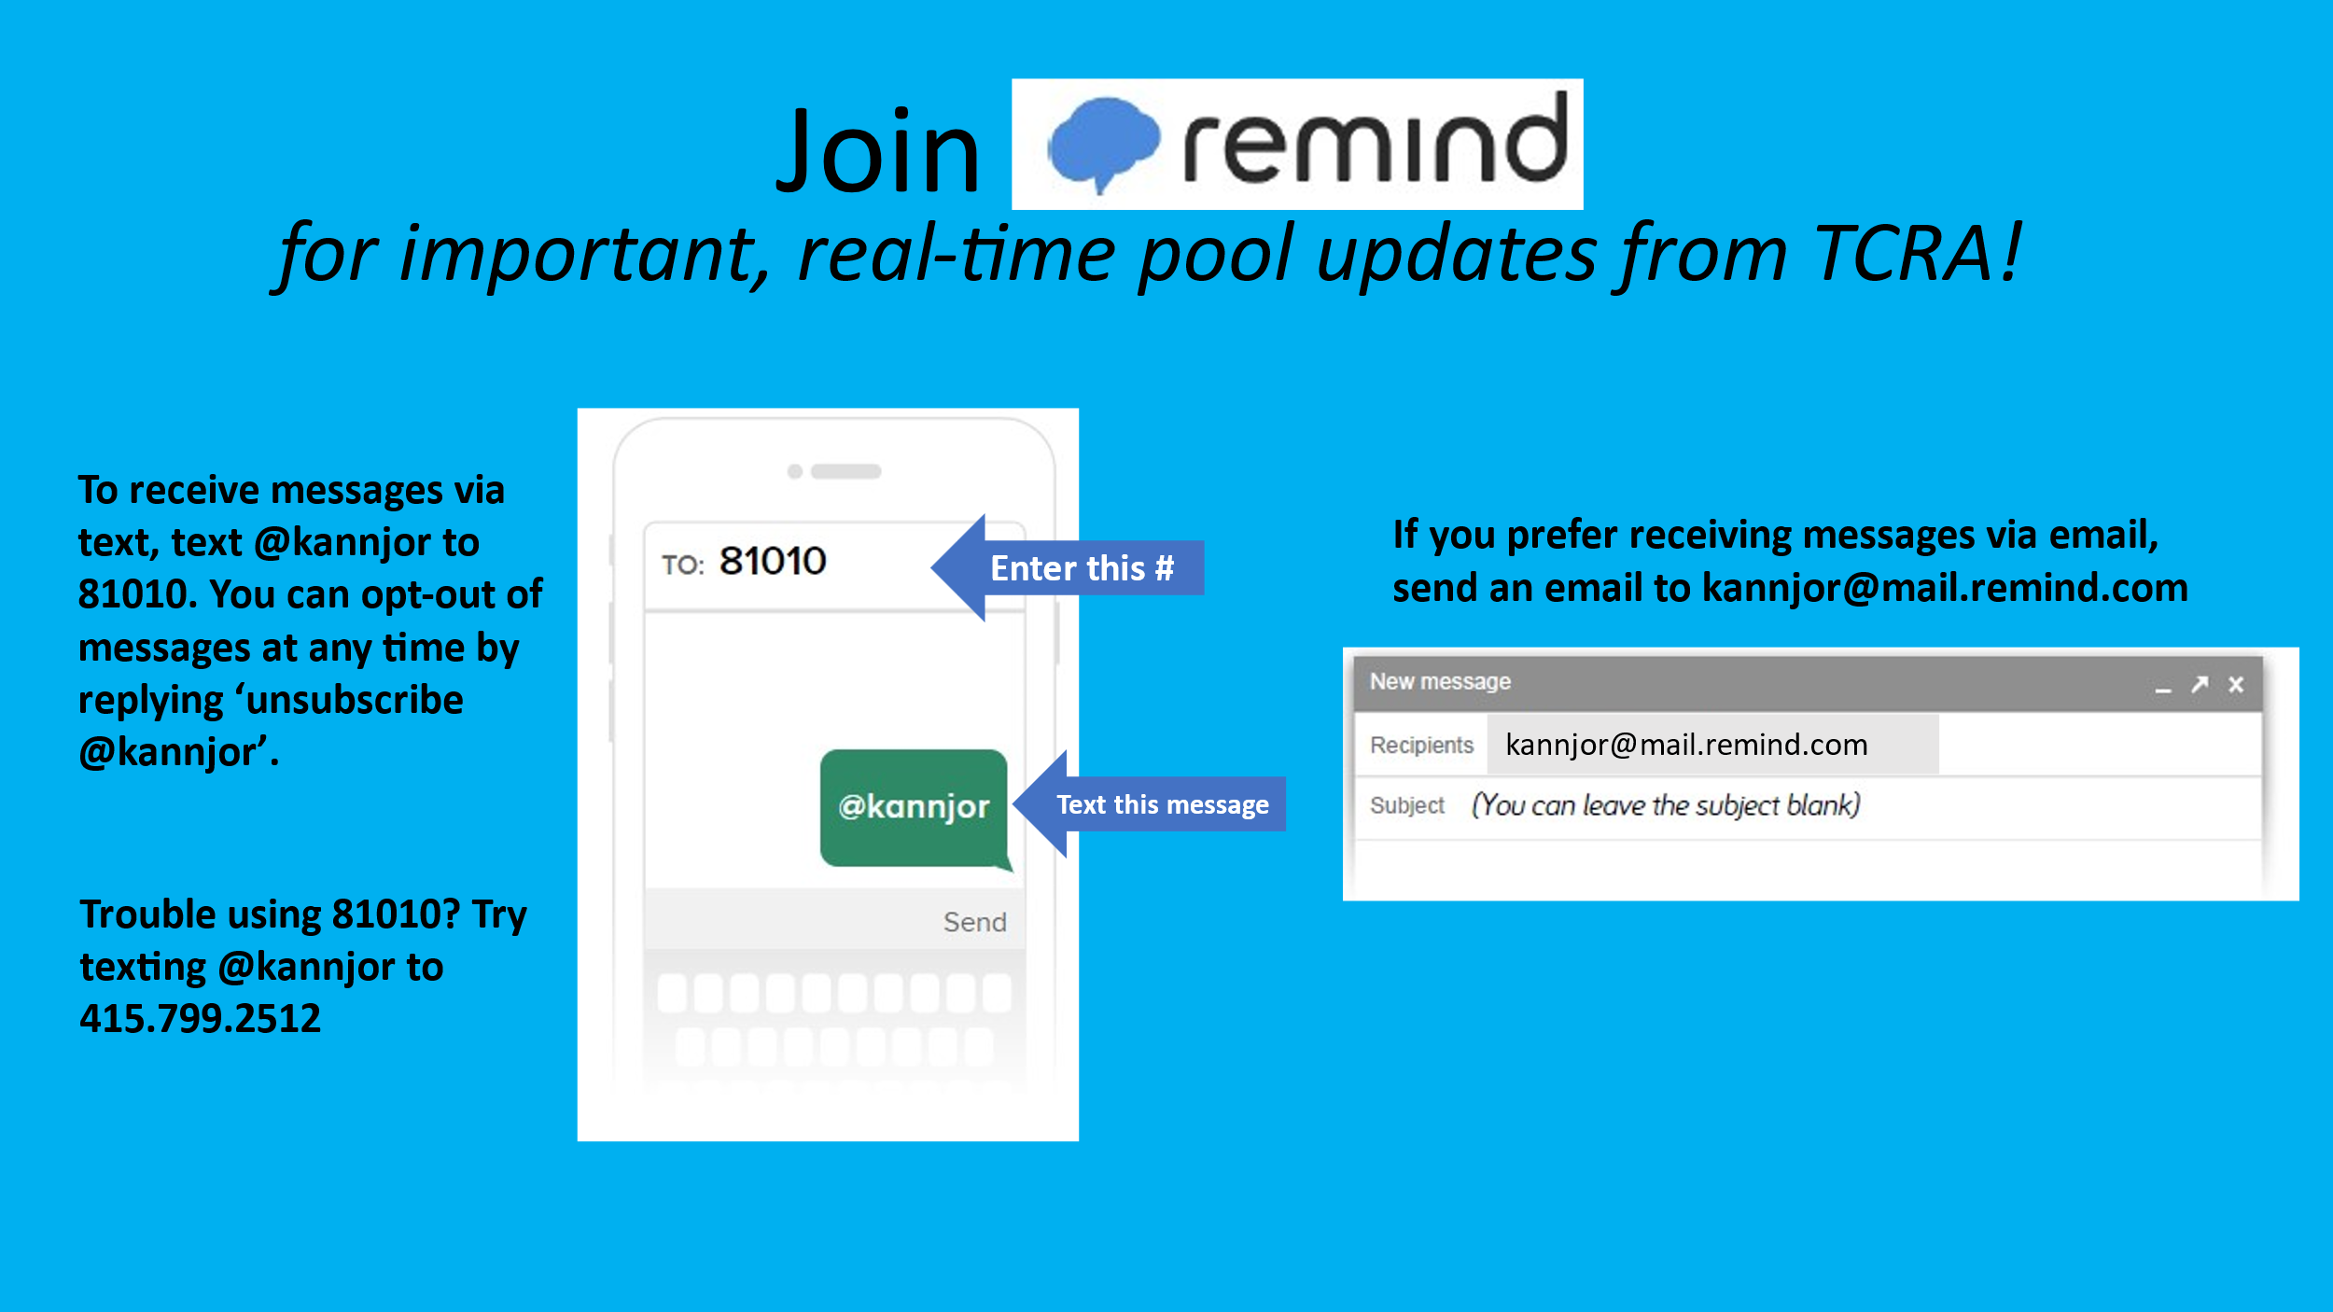

POOL RULES

Please make all family members aware of these rules.

- Use of pool and facilities are restricted to TCRA members and guests only. Guests cannot be residents of Timber Cove, Lake Country or Taylor Lake Estates because they are eligible to be pool members. If you have rented the pool for a party, these residents are allowed as your guest.

- If no lifeguard is on duty, no one under 21 years of age allowed in pool area without being accompanied by a pool member 21 years of age or older.
- Use pool at your own risk. TCRA is not responsible for injuries or accidents.
- Lifeguards are to be obeyed at all times. Disciplinary action will be left to the discretion of the lifeguard.
- If no lifeguard is on duty, swim at your own risk.
- No children under 8 years of age allowed without adult TCRA member supervision.
- Unsupervised children may not loiter in pool house.
- No animals allowed.
- No eating, drinking or smoking in the pool.
- No running, pushing, dunking or other horseplay in pool area.
- No diving off the shallow end of the pool.
- One diver on the board at a time. No diving unless the deep end is clear of all swimmers.
- Diving Board closes at 10:00 pm. Do not use the diving board after 10:00 pm.
- No bicycles, skateboards, rollerblades, scooters, etc. anywhere inside the pool area.
- No glass containers in the pool area.
- Violation of any pool rule may result in a warning, immediate expulsion from the pool area, or having membership revoked.

- Please cleanup after yourself. Please dispose of cigarette butts after extinguished into a trash container. The pavilion floor or the pool is not considered a trash container.

- TCRA reserves the right to deny use of the pool to anyone at any time.
- Dial 911 in case of an emergency

Security surveillance provided by Lakeview Police Department

RULES FOR ACCESSING THE POOL AFTER LIFEGUARD HOURS

- The TCRA pool code is a privilege for adult paying members. Do not give your code to anyone under 21 years of age. If you see children, teenagers or individuals under 21 using a code, please report it to a TCRA board member.
- For safety reasons always keep the front door closed at all times when a lifeguard is not on duty. This means not leaving the door open while there is not a lifeguard on duty.
- If you note any problems during your visit, please contact a board member.
- When you leave:
  - Make sure the pool area is clean
  - Place trash in garbage area next to the pump room
  - Turn off lights
  - Lock all the doors and gates
- Failure to adhere to these rules may result in the member’s revocation of membership for the year.

Pool Rental and Party Rules

Go to www.timbercovepool.com and click on the “Calendar” tab to check pool availability. After you check the availability, please contact Jane Brant by text (preferred) or telephone call at 832-715-0919 or email at brantjane@yahoo.com. If the pool is available, please click on the “Forms” tab on the website to download and read the Pool Reservation Form or click here. Deliver the completed form and payment to Jane at 1038 Shorewood Dr. to confirm your reservation.

The Timber Cove Pool may be rented by members for private parties, starting at 6:00 p.m. The private party fee is $100.00 with a $50.00 deposit. The fee for a party during pool hours (limit 20 guests for 2.5 hours) is $75.00 with a $50.00 deposit. Two separate checks, payable to TCRA. If the pool area is left clean, and all trash is carried to the garbage area next to the pump room, the deposit will be refunded.

Private Parties: 6:00 pm or after (including setting up for your party). $100.00 rental fee

Since we want to keep the pool available to all members, we will not rent the pool for private parties on consecutive nights. The pool may be rented only once during a weekend *(Friday – Sunday). The pool may be rented only once during the week (Monday-Thursday). *The pool may not be rented on holidays during the week or holiday weekends (Last day of school, Memorial Day, Mother’s Day, Father’s Day, July 4th, Labor Day). Please refer to the website calendar for the most up to date pool party reservations and pool availability.

If you rent the pool for a party and your guests will be swimming, you must hire a lifeguard. One lifeguard is required for each 20 people who will be swimming. Contact Sarah McGregor at sporkery@yahoo.com or 832-452-6708 for a list of lifeguards. Lifeguards are to be paid by host member directly to lifeguard and hourly rates are determined between host member and lifeguard. (Usually $10.00 hour)

During your party, if you do not wish members to come in, please hang up a “pool closed” sign.

Regular Pool Hour Parties (12:00 – 6:00 pm) $75.00 rental fee for 2.5 hours maximum
The pool may be rented during Regular Pool Hours (12:00 pm – 6:00 pm) for parties of 10 guests to a maximum of 20 guests for a fee of $75.00 for 2.5 hours. These gatherings are typically kid’s birthday parties, please remember parents who accompany your invited guests are part of your guest count. Please be considerate and leave empty tables for members who are not involved with the party. The member host is responsible for securing an additional lifeguard for the full duration of the party and for payment of the lifeguard. Hourly rates are determined between host member and lifeguard.

How many guests can I bring without it being a “party”?
Members are allowed to bring guests to the pool. A guest is someone who is not eligible for TCRA membership. Ten (10) guests or more per family membership is considered a party and requires a party reservation. Contact Sarah McGregor at sporkery@yahoo.com or 832-452-6708 for a list of lifeguards. Any lifeguards hired that are not current employees of TCRA must provide the TCRA Lifeguard Coordinator with a copy of his/her current Lifeguard and CPR Certifications.
The member hosting the party must be present for the duration of the party and clean-up.
2024 Timber Cove Dolphins Swim Team
Practice Times and Swim Meet Schedule

PLEASE NOTE: The pool is unavailable to TCRA members during swim team practices and home swim meets

Swimmers interested in joining the swim team can find more information and register online at www.timbercovedolphins.com

Annual Season Kickoff Parent Meeting
April 22 at 7:00 pm at the Timber Cove Pool

Swim Clinic
April 22 -26, 4:15 – 5:30 pm

Practice Times
Prior to End of School Year: May 1 - 30
Monday-Thursday
4:30 pm – 7:30 pm

After School Year Ends: Monday, June 3 - July 5
Monday – Friday
7:00 am- 10:00 am

Please refer to the swim team website for age group practice times

Swim Meet Schedule
June 1 Away
June 8 Home Pool unavailable Friday 7:00 pm-Saturday 2:00 pm
June 15 Home Pool unavailable Friday 7:00 pm-Saturday 2:00 pm
June 22 Away
June 29 Home Pool unavailable Friday 7:00 pm-Saturday 2:00 pm
TBD 6:00 End of season party at the pool

PLEASE NOTE: Date and time changes can be found at www.timbercovedolphins.com
Or refer to the pool calendar www.timbercovepool.com

Please get the Remind app to receive real time pool update from TCRA

